Problem :

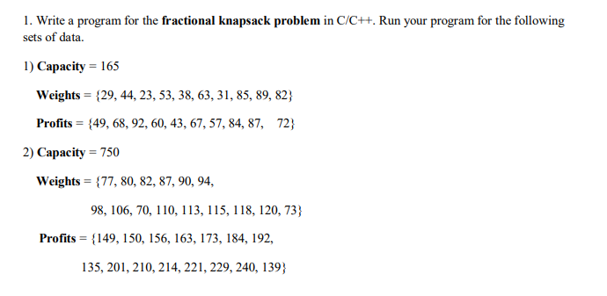

Programm :

A-1. OUTPUT OF THE FIRST DATA SET :

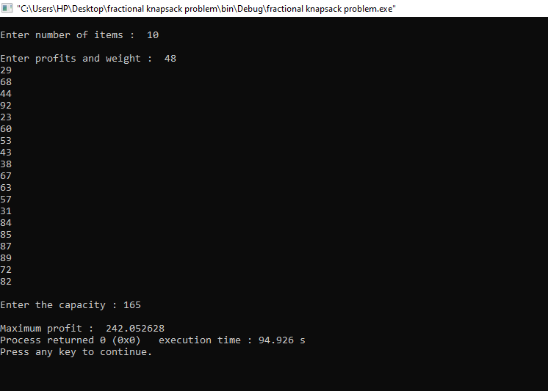

a-2.

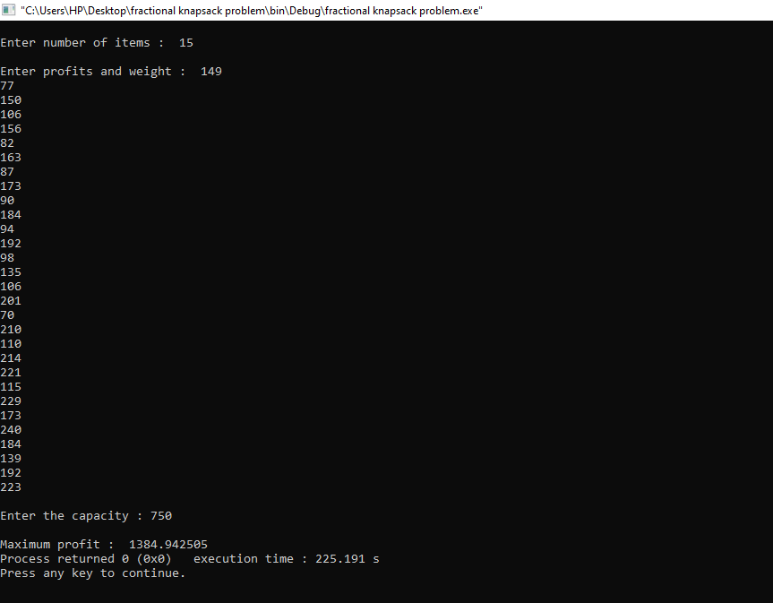

b) Describe the design method of your program

Using C

c) Give the code of your program

# include<stdio.h>

void maximumprofit (int n,float weight[],float profit[],float capacity)

{

float x[100], tp=0;

int i,j,u;

for (i = 0; i < n; i++) {

if (weight[i] > capacity)

break;

else {

printf(" \nTaken items number %d",i);

tp = tp + profit[i];

capacity = capacity - weight[i];

}

}

if (i < n)

x[i] = capacity / weight[i];

tp= tp + (x[i] * profit[i]);

printf("\nMaximum profit : %f", tp);

}

int main()

{

float weight[100],profit[100],capacity;

int n,i,j;

float ratio[100],temp;

printf("\nEnter number of items : ");

scanf("%d", &n);

printf("\nEnter profits and weight : ");

for (i = 0; i < n; i++)

{

scanf("%f %f", &profit[i],&weight[i]);

}

printf("\nEnter the capacity : ");

scanf("%f", &capacity);

for (i = 0; i < n; i++)

{

ratio[i] = profit[i] / weight[i];

}

for (i = 0; i < n; i++) {

for (j = i + 1; j < n; j++)

{

if (ratio[i] < ratio[j])

{

temp = ratio[j];

ratio[j] = ratio[i];

ratio[i] = temp;

temp = weight[j];

weight[j] = weight[i];

weight[i] = temp;

temp = profit[j];

profit[j] = profit[i];

profit[i] = temp;

}

}

}

maximumprofit(n, weight, profit, capacity);

return(0);

}